MULTISITE GRANT MANAGEMENT SYSTEM

User Guide Document

Ver. 1.4

Version History
Date | Description
20-Oct-2010 | First Draft
11-Feb-2011 | Changed screens and flow – sections moved into Project Info page

Table of Contents

Version History 2
1 Introduction 4
1.1 Purpose 4
2 Create Project – grantor/self 4
2.1 Add co-PI to the Project 5
2.2 Add project to Department 5
2.3 Fund Allocation 6
3 Project - Grantee 6

Introduction

Purpose

This document provides the step-by-step instructions for submitting utilization reports through the Multisite Grant Management System.

Please note that this is a ‘living document’ and the specification will change, continuously, as the project proceeds. More details will be added and the existing information edited as the requirements, scenarios and use cases evolve in the course of the project.

Create Project – grantor/self

This feature is used by an institution to save details of a project which is expected to be run with in the institution funded by self or by an external funding agency which does not use the MGMS as well.
The site admin is provided with the privilege of creating new projects
On the left navigation menu, click Projects, and further, Create Project. Fill in the mandatory details and click Create.

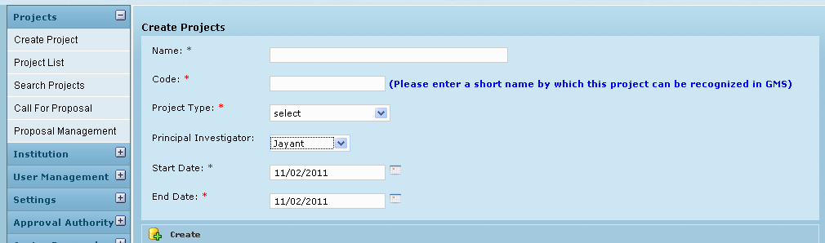

A message is displayed explaining that the project has been created successfully. Now returning back to Projects List page, the newly created project can be seen in the list.

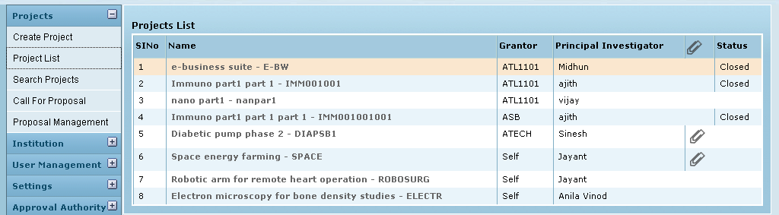
Click on the Project Link

Clicking on the project name (link) will open the Project Home – where all further activities related to project can be done.

Add co-PI to the Project

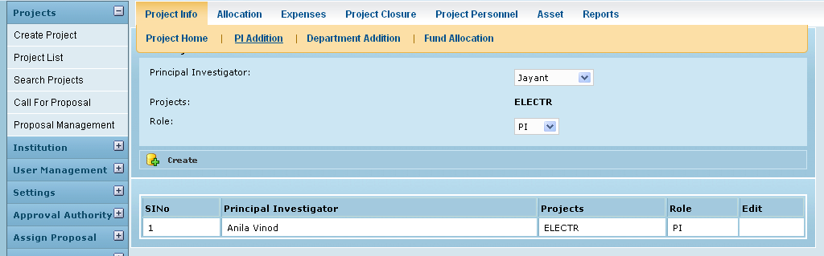

For the allotted project Grantee can add their own co-PI.

Co- PI are added to the project and listed below. Now once the site admin assigns permissions for the specific project, the co-PI will get the project in his login.

Add project to Department

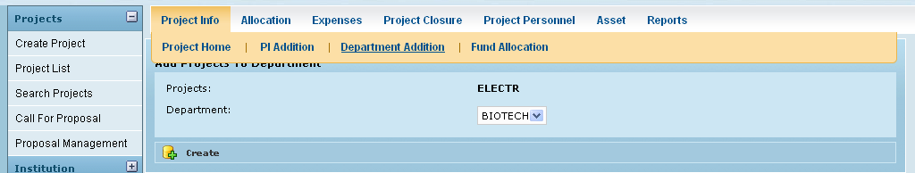
Click on create button after selecting project and department. Then the project is assigned to the department and listed below.

Fund Allocation

On creating a project, an automatic allotment of zero amount is made by the system (line item in the table below). The user can edit this allotment and save the actual details of fund allocated for the particular project.

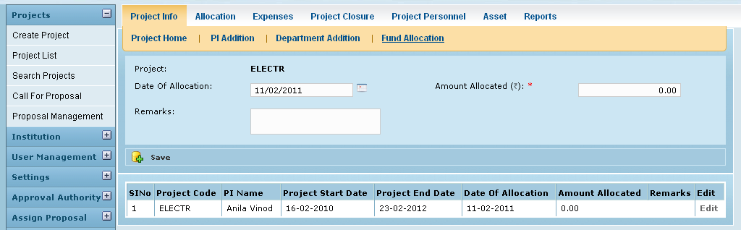

Project - Grantee

When a project has been sub allocated to the institution or been allotted fund by an external funding agency which is part of the MGMS, the project is created by the grantor and the project gets displayed in the project list automatically in the site admin’s and PI’s log-ins. (shown below)

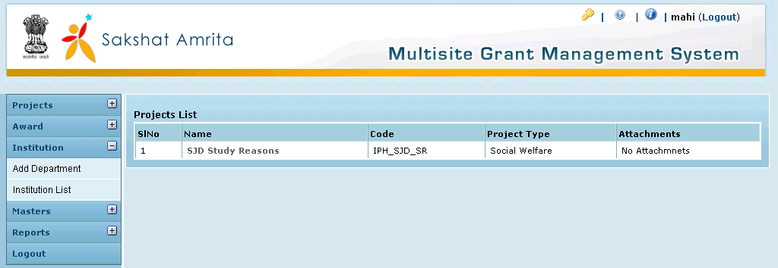

As in the case of self created projects, co-PI and departments can be added to the project, but fund allocation will already have been done by the grantor. Only grantor can edit

